AZURE BACKUP AND BUSSINESS CONTINUITY

High availability : High availability in Azure is the ability of your applications and services to remain online and accessible with minimal downtime, even in the event of a system failure.

Disaster Recovery : Disaster recovery is a comprehensive plan to restore an organization's IT infrastructure and data after a major event, like a natural disaster, cyber attack, or critical equipment failure.

Azure Backup : Azure Backup is a cost-effective, cloud-based solution that protects data on-premises and in the cloud. It provides secure, automated, and scalable backups that can be easily restored.

Types :

* Full Backup : Creates a complete copy of the data source. This takes the longest time and uses the most storage space, but offers the fastest restore time because all data is in a single backup set.
* Incremental Backup: Backs up only the blocks of data that have changed since the *previous* backup (which could be a full or an incremental backup). This is the most storage- and network-efficient method, as it does not store redundant copies of unchanged data.
* Differential Backup: Captures all data that has changed since the last full backup. It is more storage- and network-intensive than an incremental backup, but restores faster because it only requires the last full backup and the latest differential backup.
* System State Backup : A system state backup captures operating system files, enabling recovery if a machine starts but has corrupted system files or a lost registry.
* General Data/File Backup : This type of backup captures specific files and folders, but does not include system-critical data.
* Azure Backup Services :
* Recovery Services vault
* Backup vault
* Microsoft Azure Recovery Services (MARS) agent
* Microsoft Azure Backup Server (MABS)
* System Center Data Protection Manager (DPM)
* Backup Center
* Azure Site Recovery (paired with backup for disaster recovery)
* Azure Disk backup (managed disk snapshot)
* Azure Files backup
* Azure Blob storage backup

Azure Recovery Service Vault : Azure Recovery Services vault is a storage and management entity within Azure that acts as a central hub for your backup and disaster recovery processes.

How to create Backup Vault?

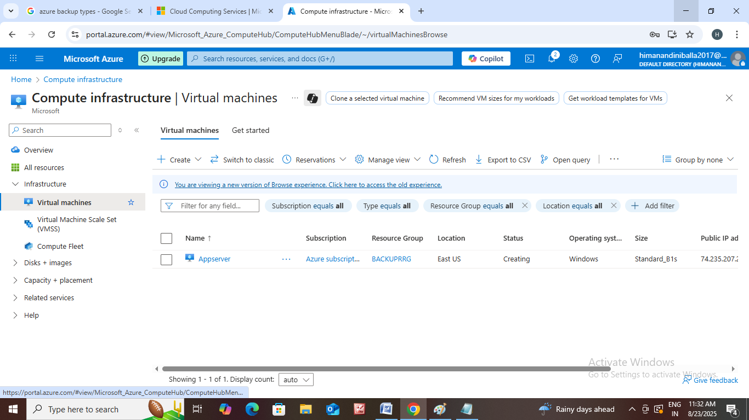Go to https://azure Microsoft.com.

• First we have to create virtual machine.

• Go to home and click on virtual machine. zz

• Resource group name : backuprg

• Virtual machine name : Appserver

• Choose and select your region, availability zone ,

security type, and image.

• Then click on next.

• In disks choose Os disk type, Os disk size.

• Then click on create.

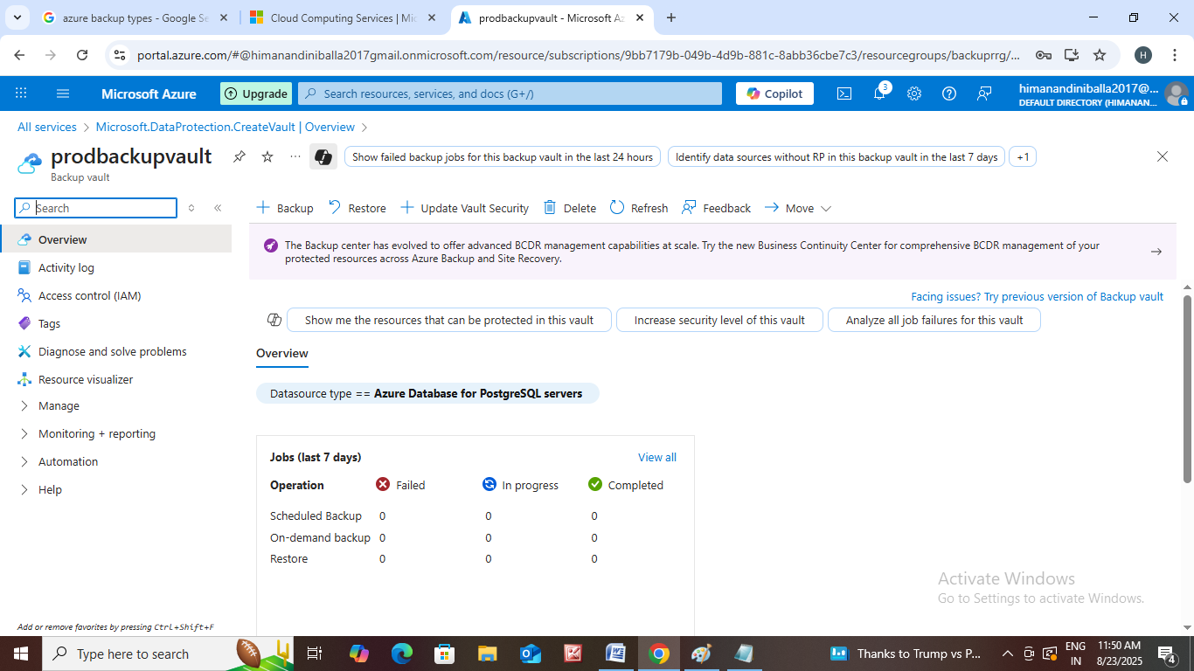Next create Backup Vault.

• Go to all services and click on backup vault.

• The page is open then click on create.

• Select same resource group we used in VM.

• Name that backupvault like ex: prodbackupvault.

• Choose which region do you want.

• Choose backupvault redundancy themn click on next.

• We can enable soft delete and mention how many days did you want.

• Name that tag.

• Then click on create.

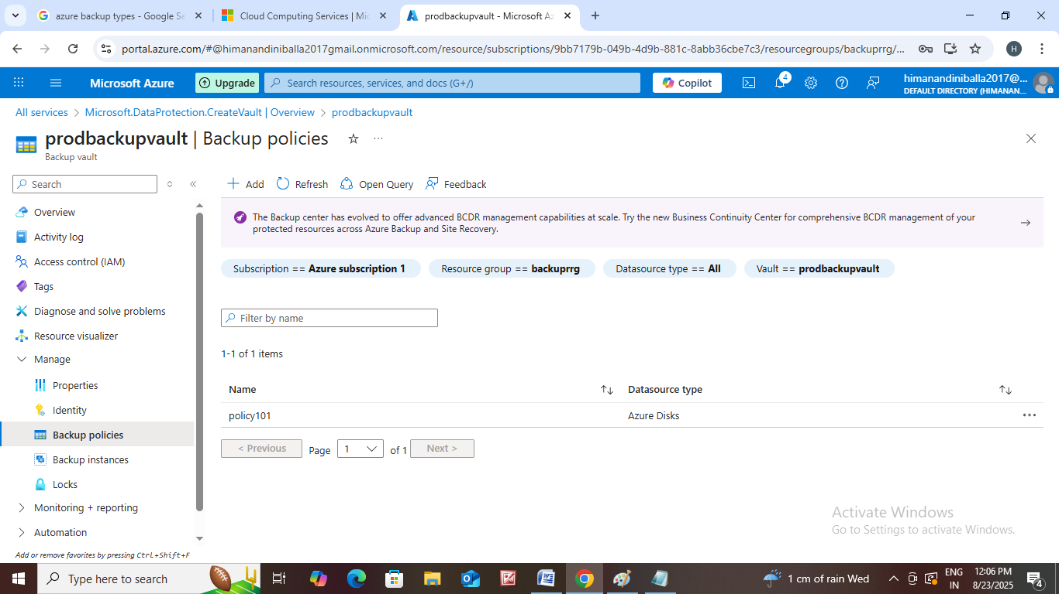Now let us create backup policy.

• Go to overview page of backup vault.

• Scroll down we can see backup policy option click it.

• Add the policy.

• Name that policy and select data source type.

• Then click on next.

• Which type of backup schedule you want we can select it.

• Then click on create.

Next let us create Backup instance

* Go to overview page of backupvault.
* Scroll down we can see backup instance option click it.
* Click on backup.
* Choose datasource type and vault.
* Click next enter your backup policy.
* Then click next add your datasource and select it.
* Next go to all resources click on your appserverosdisk and select IAM and add role assignment.
* Then create it.

Next Let us create Recovery Service Vault

* Go to home search for recovery service vault.
* The page is open then click on create.
* Select your resource group, region and name that vault.
* Then click on next name that tags.
* Then click on create.
* After creating clickon that prodrecoveryservicevault then we see protected items option.
* Then click on it under that we can see backup items and replicated items.
* In backup items which type of backup management we can select it.
* Then click on add we can select your workload and which type did you want backup select it.
* Then click on prepare infrastructure and download it.
* In replicate files we can replicate files and servers.